Research Analysts:
Joshua Onyirimba & Madhu Kannan
joshua.onyirimba@uconn.edu & Madhumitha.kanna@uconn.edu

Student Managed Fund
Salesforce (NYSE: CRM)
November 29, 2021
Target Price: 331.4
Current Price: 297.53
Stop loss: 25%
52 Week High/Low: $201.51- $311.75 P/E Ratio: 119.34
EPS: 2.50
Book Value/Share: 56.77
Company Overview
Salesforce is a leading provider of enterprise cloud computing solutions, with a focus on customer relationship management, or CRM. Delivering solutions as a service via all the major Internet browsers and on leading mobile devices. Selling to businesses of all sizes and in almost every industry worldwide on a subscription basis, primarily through our direct sales efforts and indirectly through partners. Their Subscription and Support Services account for nearly 95% of total revenue and customers in the Americas account for more than 70% of total revenue.
Industry Outlook

The global customer relationship management market size was valued at USD 43.7 billion in 2020 and is expected to expand at a compound annual growth rate (CAGR) of 10.6% from 2021 to 2028. This growth is driven by the growing importance of understanding customer behavior and preferences amid the intense competition is prompting brands and organizations to adopt CRM strategies to deliver the best service performance in real-time and stay ahead of their rivals. The growing use of digital channels by customers to communicate with brands and organizations is estimated to boost the customer relationship management (CRM) market growth over the forecast period. Industry estimates suggest that around 91% of organizations with more than 10 employees in their workforce use CRM systems.
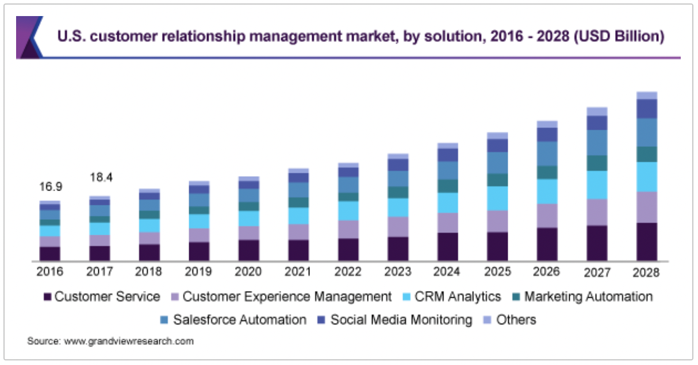
Market Share
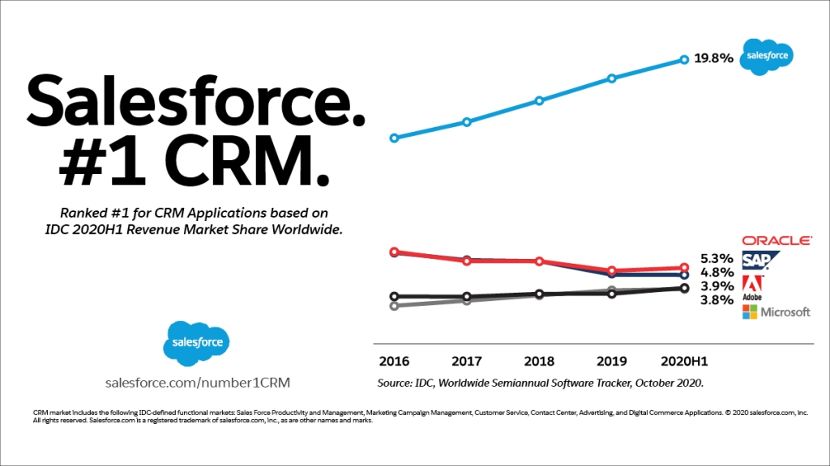

Investment Thesis
Salesforce is the clear market leader in the rapidly growing customer relationship management industry. They work with over 150,000 businesses of all sizes and their subscription services account for around 95% of total revenues. Sticky customers are an industry characteristic, further driving our optimism on the company as a whole.
Salesforce is recognized for having the best product in the industry. They are expanding their solutions offerings through their inorganic growth strategy, highlighted by the acquisitions of Slack, Tableau & Vlocity over the past three years.
With over 70% of total revenue coming from the Americas, Salesforce is positioning itself to increase its global presence. The implementation of the global advisory board aims to obtain strategic guidance and support as it grows into new markets, deepening Salesforce’s role as a trusted digital advisor to CEOs and leaders around the world.
The annual term structure of the subscription services makes seasonality a factor in the performance of the company and further drives our optimism. According to their annual report, the company’s fourth quarter has “historically been our strongest quarter for new business and renewals” and their first quarter is their largest collections and operating cash flow quarter”

Investment Risks
The five main areas of risk for Salesforce lies within third party issues, security issues, legal risk, and increased competition. While none of these issues have caused any significant issues, it is important to be aware that they do exist. Salesforce takes great precaution to provide security over their client’s data and remains the top CRM provider in the industry. As this software becomes more popular, larger competitors aim to imitate CRM software. However, Salesforce's tenure in this field has allowed them to perfect their technology.
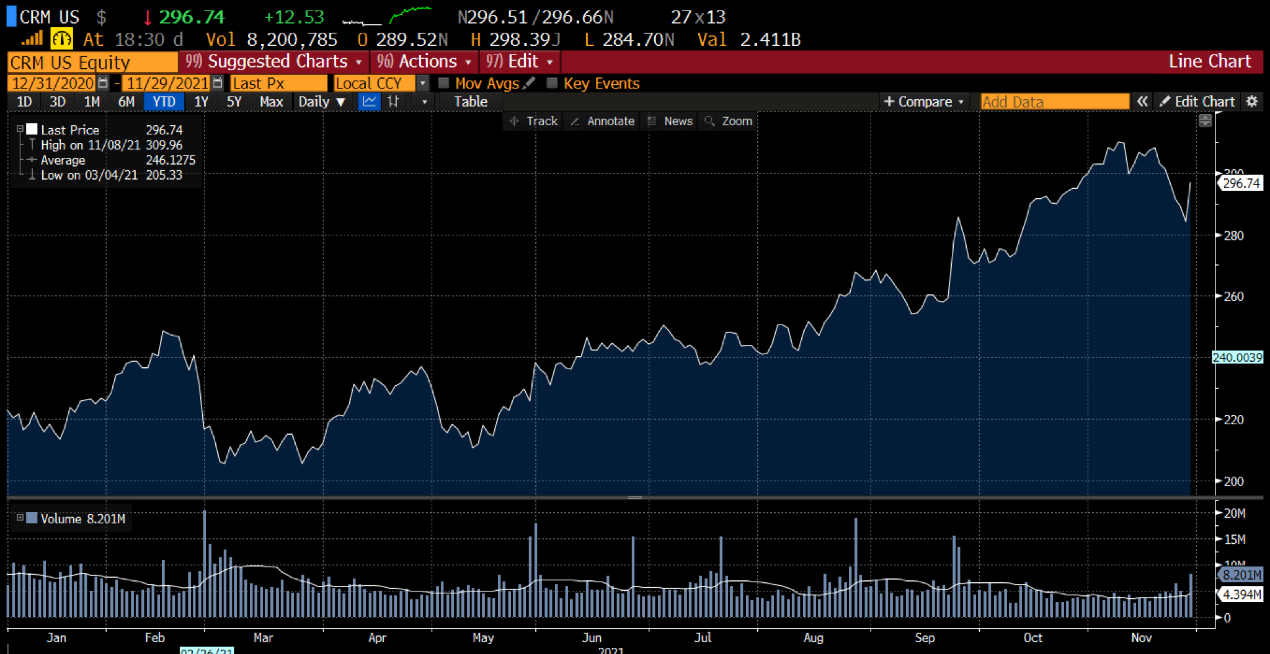

l
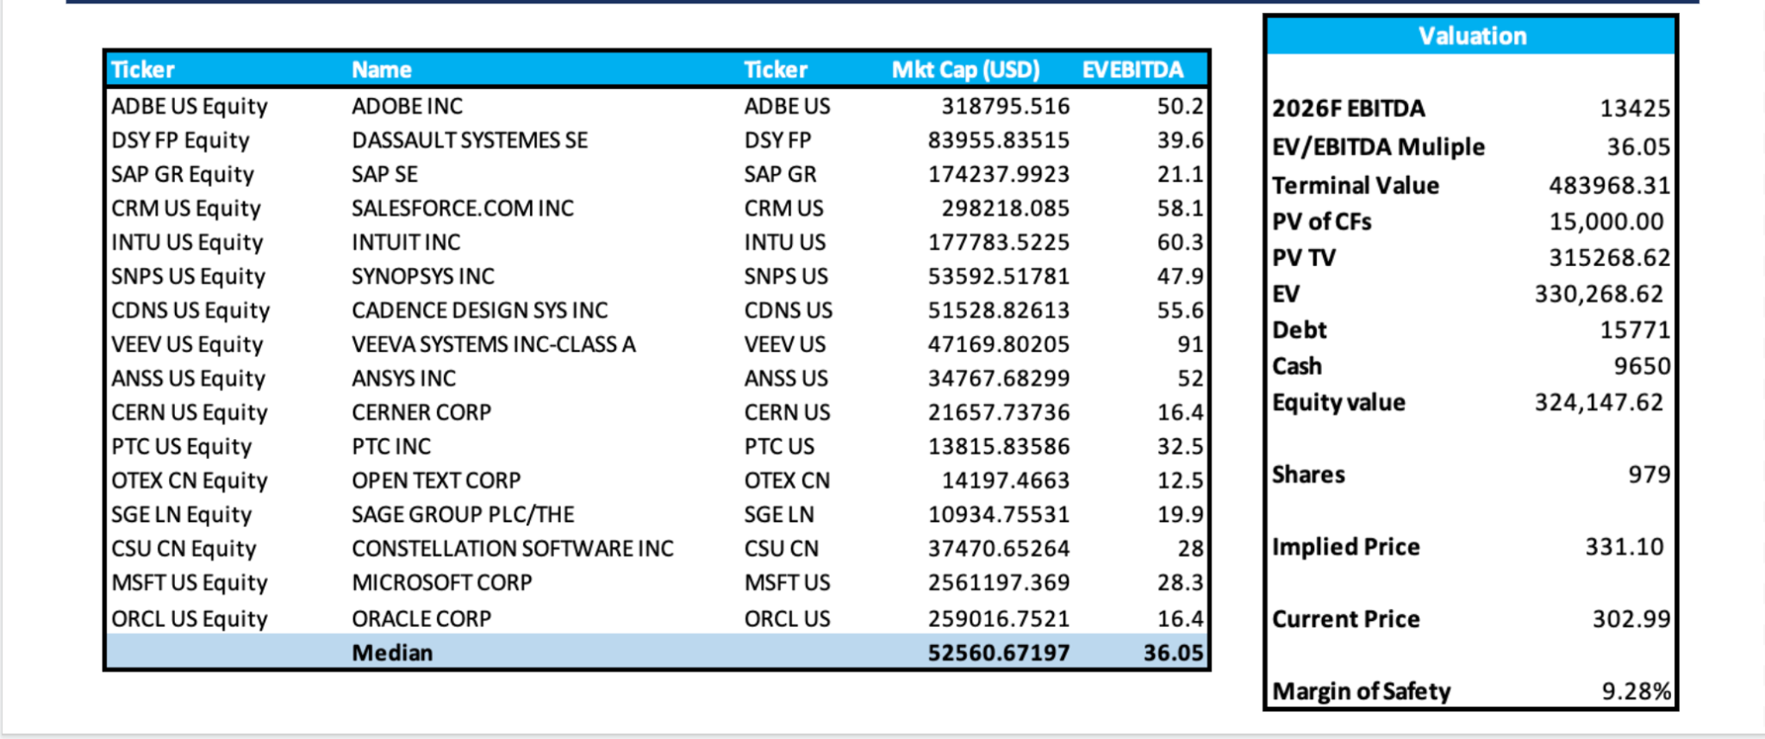

ESG Considerations
Salesforce prioritizes ESG standards through several internal initiatives. The company uses a Net Zero energy platform which delivers a carbon neutral cloud to its customers. The company also uses a one-one-one model for their philanthropic efforts to encourage themselves and their clients to direct 1% of their product, time and resources towards integrating businesses. Salesforces has also been on the Fortune 100’s “top companies to work for” for the past thirteen years.
