Research Analysts:
Alex Bielak & Chrisitian Bray
alexander.bielak@uconn.edu & christian.bray@uconn.edu
UConn Undergraduate Student Managed Fund Caterpillar (NYSE: CAT)
March 11, 2022
Target Price: $240.47
Current Price: $212.30
Stop loss: 25%
52 Week High/Low: $179.67- $246.69 P/E Ratio: 18.78
EPS: 11.83

Company Overview
Caterpillar Inc, is one of the world’s largest manufacturers of construction and mining equipment. Caterpillar Inc, generates revenue in two ways 1) the sales and serving of their machinery and equipment which is where a significant portion of their revenue is derived from and 2) financial services which offers financial products and services for dealers and customers. Caterpillar is a global company and using its geographic reach and scale extremely effectively, approximately 25% of revenue is generated from Europe, Africa & Middle East, 25% from Asia/Pacific, 10% from Latin America and the remaining 40% from the United States.

Industry Outlook
The global machinery industry has an addressable market size of $565.6B, and is expected to have a 7 year CAGR of 5% causing the estimated market size to reach $794B by 2027. The operating segments’ expected CAGR are between 4 - 6% representing growth inline with our economy to slightly higher. The short term growth drivers include the US infrastructure bill that is expected to create at least $27B in new opportunities, inventory backlog of 23.1B, and equipment turnover of one of the worlds’ largest mining equipment fleets. Due to machinery being a mature and well established business it is an extremely competitive industry and operates in a cyclical nature. The five largest direct competitors to Caterpillar Inc, are Deere & Co, CNH Industrial NV, Komatsu LTD, Atlas Copco Ab, and Kubota Corp, however many of these companies are only directly competing with select products are they do not have the scale to offer the sames diverse service and product offerings.

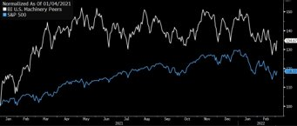

Infrastructure Spending Predictions
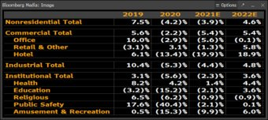

Investment Thesis
Caterpillar is the global leader in market share within the heavy machinery and construction industry, currently holding a 13% market share. This market share is underpinned by both intangible assets and high switching costs for customers. As the company has nearly a century of experience, Caterpillar has established a large dealer network and has been able to alter product offerings to cut costs for specific customer segments. Caterpillar has over 160 dealers, spanning 190 countries that usually only sell Caterpillar products. It is difficult for other companies to achieve a similar dealer network because in order to do so, they would need a product breadth similar to CAT, which has generally not been seen to this point. Caterpillar now offers 3 different product variations within their construction equipment portfolio through their lifecycle performance, lifecycle value, and utility application brands. For example, their lifecycle performance brand is meant for customers that measure success by cost per work completed. These customers are willing to pay more up front for equipment that has high specifications and features, and can operate around the clock. These product offerings have strengthened Caterpillar’s brand and competitive advantage. Additionally, positive industry and economic trends point to success for Caterpillar. Nonresidential construction spending is expected to increase 4.6% in 2022 accompanied by expected growth in other construction sectors after decreases in the past two years. Additionally, extended backlogs (~$23 billion) and lean dealer inventories point to strong demand. The $1.2 trillion infrastructure bill passed in November likely won’t be the only fiscal stimulus dedicated to infrastructure. The bill allocates $550 million in new federal spending with $284 billion for transportation and $110 billion for roads & bridges. In the short term, this bill is projected to add an incremental 1-2% to construction equipment manufacturers sales. Typically, 5-7 cents of every dollar spent on infrastructure goes towards equipment.

Historical Performance and Valuation
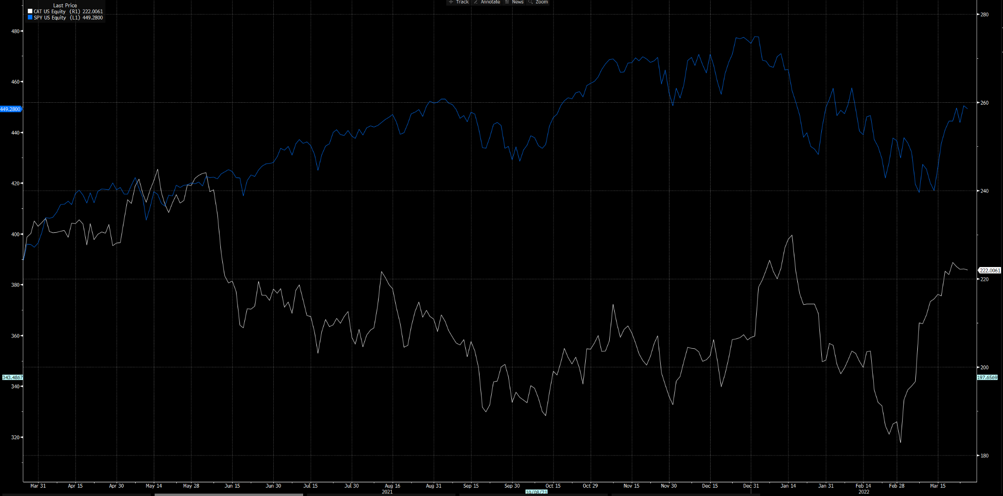
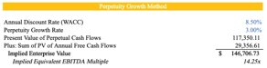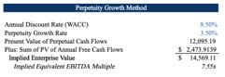
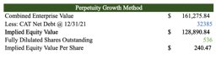
Investment Risks
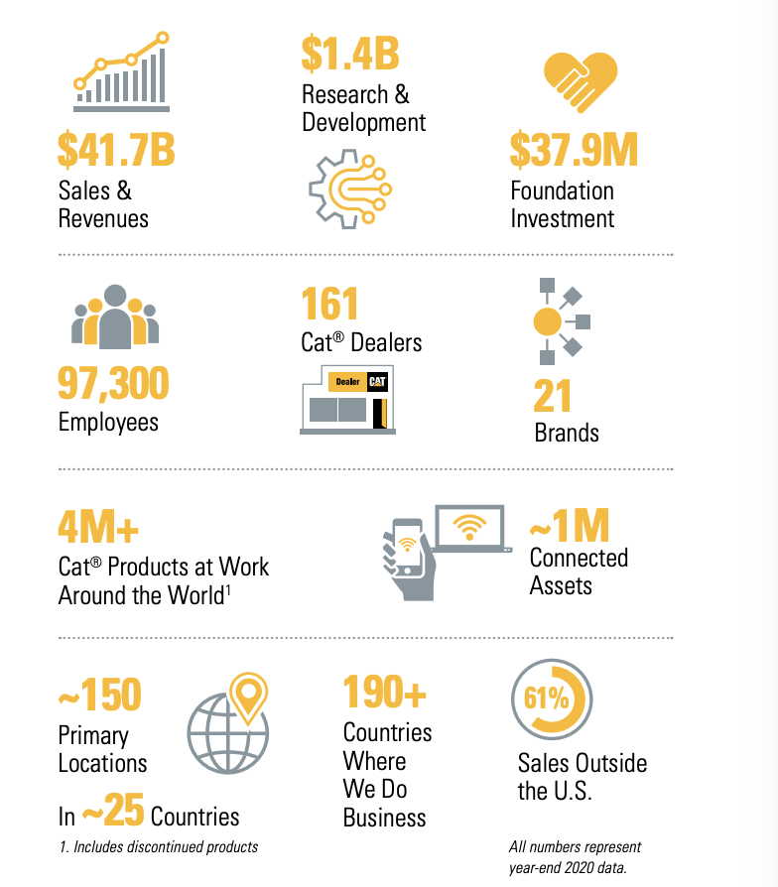
One of the biggest risks surrounding Caterpillar’s business is cyclicality. In 2012, revenues totaled just under $66 billion however in 2016, revenues were just $38 billion. Caterpillar attributed this dramatic decline to weakening economic growth (specifically in Brazil and China) and substantially lower commodity prices which drove down demand for their products. Caterpillar’s emphasis on their Services business should help alleviate cyclicality as they will be providing products and services in times where demand for equipment is lower. Another risk is the expected decline in mining capital expenditures. Improving commodity prices will hopefully boost mining confidence and encourage replacement of the oldest fleet age in history. Trucks, electric shovels, wheel loaders, and dozers for example, are all at their oldest ages recorded. This will hopefully prompt more demand for this equipment.
ESG Considerations
Caterpillar prioritizes ESG standards and is a leader within an industry that is reevaluating a lot of their previous established practices. Caterpillar has implemented several internal initiatives in order to improve their governance, social and environmental impact. Caterpillar Inc, has been included on the DOW Jones Sustainability Index for over 20 years, employees over 97,000 people across 21 brands, taken back 131 million pounds of material for remanufacturing, 51% reduction in absolute greenhouse gas emissions from 2006, and 43% reduction in absolute water consumption form 2006.

